1. **Problem Statement**

In C/C++ we are tasked to program which implements the banker's algorithm (Section 6.3). Verify your implementation using the data from the textbook as well as the attached, but unverified (meaning that it is possible the system is already in an unsafe state).

1. **Approach to Solution**

I used header files such as fstream so we could collect our data from files. Called the sstream header file to be able to process characters in the strings into integers that could be mapped to integer arrays, and the final approach would be to implement the algorithm through research from the book and online on how the algorithm works.

1. **Solution**

The solution can be broken down into 5 sections

1. Reading from the file – we accomplished this using the fstream header file, and calling using ifstream and getline. It worked well and we were able to open and read from files.
2. Putting the contents into the array - We did that using an objects from sstream called istringstream. It worked well and we were able to put the contents into the allocation matrix, claim matrix, and resource vector respectfully.
3. Find the available array (vector) – We took the summation of all the resources currently allocated and subtracted that from the resource vector. The remaining value is our available vector which will be crucial to bankers algorithm.
4. Implemented bankers algorithm and made sure that we checked for safe and unsafe sequences.
5. Finally here is the output of the executed code

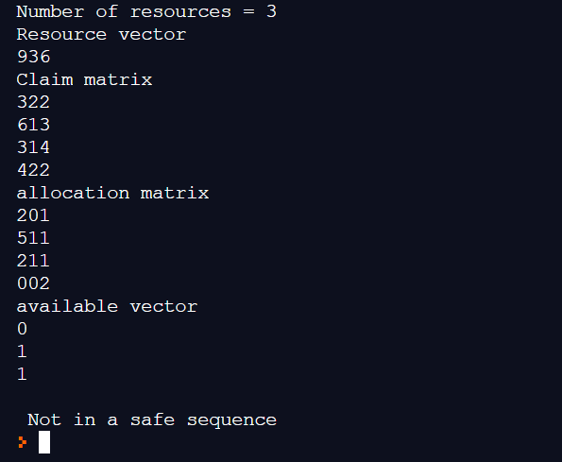

Output using information from textbook example 6.8b

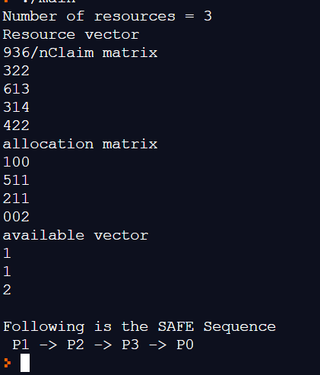

Output with information using textbook example 6.8a

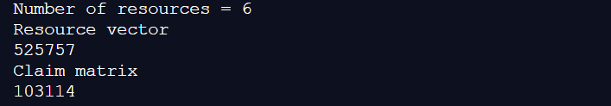

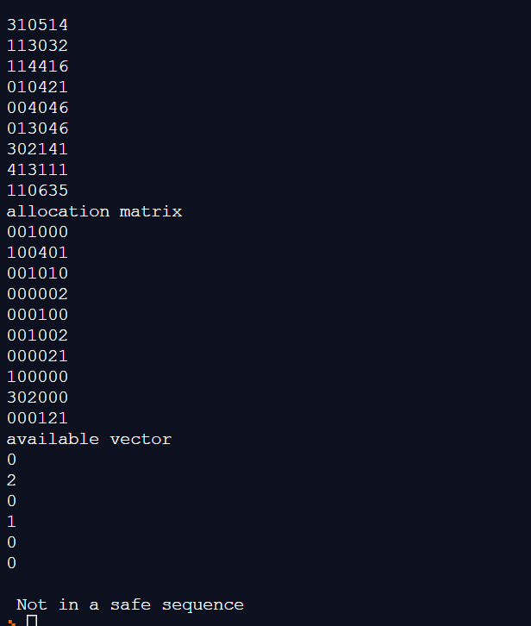

Output using code from the input given along with the program problem description

The output showed the following:

1. Number of resources
2. Resource vector
3. Claim Matrix
4. Allocation Vector
5. Available Vector
6. Determined whether the sequence was safe